Lab SHEET 05
(FULL STACK)
HIMANI CHAUDHARY , CU240250967 (24) , BTECH (CSE), SEC(B)
1. Install packages
npm init -y
npm install express dotenv
npm install --save-dev nodemon
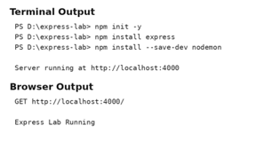
// PART A - PROJECT SETUP
require("dotenv").config();
const express = require("express");
const path = require("path");
const app = express();
const PORT = process.env.PORT || 4000;
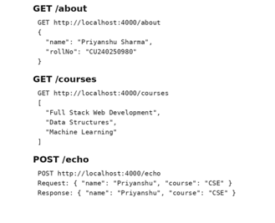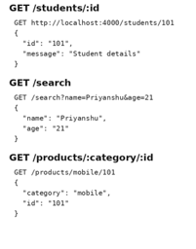
// PART D - CUSTOM LOGGER MIDDLEWARE
app.use((req, res, next) => {
console.log(
`${req.method} ${req.originalUrl} - ${new Date().toISOString()}`
next();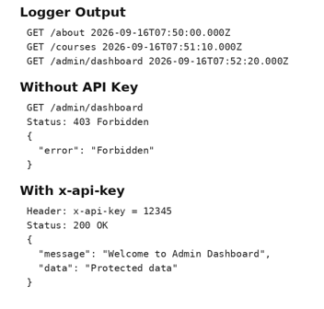
// PART E - JSON AND FORM MIDDLEWARE
app.use(express.json());
app.use(
express.urlencoded({
extended: true}
// PART I - STATIC FILES
app.use(express.static(path.join(__dirname, "public")));
// PART A - BASIC SERVER
app.get("/", (req, res) => {
res.send("Express Lab Running");});
// PART B - BASIC ROUTING
app.get("/about", (req, res) => {
res.json({
name: "HIMANI CHAUDHARY",
rollNo: "CU240250967"});
app.get("/courses", (req, res) => {
res.json([
"Full Stack Web Development",
"Data Structures",
"Machine Learning"]);
app.post("/echo", (req, res) => {
res.json(req.body)});
// PART C - ROUTE PARAMETERS AND QUERY STRINGS
app.get("/students/:id", (req, res) => {
res.json({
id: req.params.id,
message: "Student details" });
app.get("/search", (req, res) => {
res.json({
name: req.query.name,
age: req.query.age});
app.get("/products/:category/:id", (req, res) => {
res.json({
category: req.params.category,
id: req.params.id
// PART E - REGISTER AND CONTACT
app.post("/register", (req, res) => {
const {
name,
email,
password
} = req.body;
res.json({
message: `Registration successful for ${name}`,
email: email,
passwordReceived: Boolean(password) });
app.post("/contact", (req, res) => {
console.log("Contact Form Data:");
console.log(req.body);
res.jso
message: "Thank you for contacting us",
data: req.body });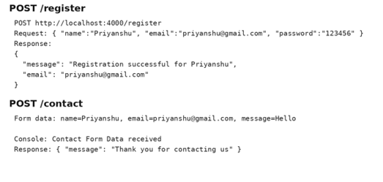
// PART F - STUDENTS ROUTES
let students = [{
id: 1,
name: "Priyanshu Sharma",
course: "CSE"{
id: 2,
name: "Rahul Kumar",
course: "BCA"{
id: 3,
name: "Aman Singh",
course: "CSE"];
// PART F - BOOKS ROUTES
let books = [
{ id: 1,
title: "JavaScript Basics",
author: "John Smith"},
{ id: 2,
title: "Learning Node.js",
author: "Jane Doe"];
app.get("/api/books", (req, res) => {
res.json(books);});
if (!book) {
const error = new Error("Book not found");
error.status = 404;
return next(error);
res.json(book)
});
id: books.length
? Math.max(...books.map(b => b.id)) + 1
title: req.body.title
author: req.body.author };
books.push(newBook);
res.status(201).json(newBook);});
return next(error); }
book.title = req.body.title ?? book.title;
book.author = req.body.author ?? book.author;
res.json(book);
});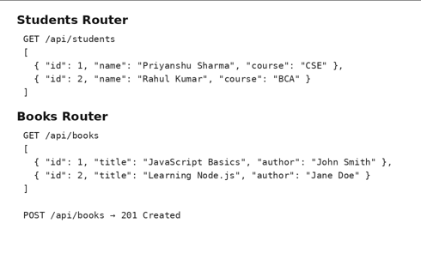
// PART G - TASKS CRUD API
let tasks = [
{
id: 1,
title: "Complete Express Lab",
completed: false
},
id: 2,
title: "Practice REST API",
completed: truee];
app.get("/api/tasks", (req, res) => {
res.json(tasks);});
if (!task) {
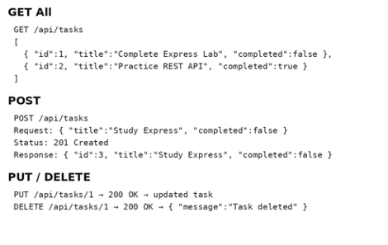
// 5. DELETE TASK
app.delete("/api/tasks/:id", (req, res, next) =>
const index = tasks.findIndex(
t => t.id === Number(req.params.id) );
if (index === -1) {
const error = new Error("Task not found");
error.status = 404;
return next(error); }
const deletedTask = tasks.splice(index, 1)[0];
res.json({
message: "Task deleted",
task: deletedTask});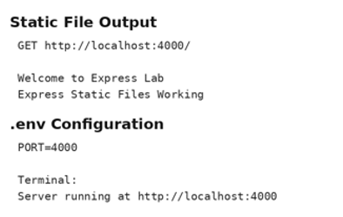
// PART J - LIBRARY MANAGEMENT MINI API
let members = [ {
id: 1,
name: "Priyanshu Sharma",
email: "priyanshu@gmail.com"},
{ id: 2,
name: "Rahul Kumar",
email: "rahul@gmail.com"}];
// DELETE member
app.delete("/api/members/:id", (req, res, next) => {
const index = members.findIndex(
m => m.id === Number(req.params.id) );
if (index === -1) {
const error = new Error("Member not found");
error.status = 40
return next(error);}
const deletedMember = members.splice(index, 1)[0];
res.json({
message: "Member deleted",
member: deletedMember});
// PART H - 404 ERROR HANDLER
app.use((req, res) => {
res.status(404).json({
error: "Route not found"});
// PART H - CENTRALIZED ERROR HANDLER
app.use((err, req, res, next) => {
console.error("ERROR:", err.message);
res.status(err.status || 500).json({
error: err.message || "Internal Server Error" });
